Criterion-7 Institutional Values and Best Practices
Metric  Number | Institutional Values and Social Responsibilities | Supported Document
7.1.1 | Measures initiated by the Institution for the promotion of gender equity  during the last five years | Women’s Grievance Redressal Cells Compliant form, Rules, Annual Gender Sensitization Action Plan, Minutes of meeting, Notice, Reports, Press release

Committees
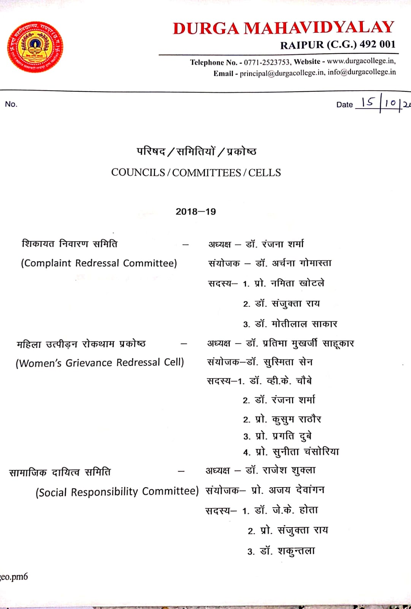

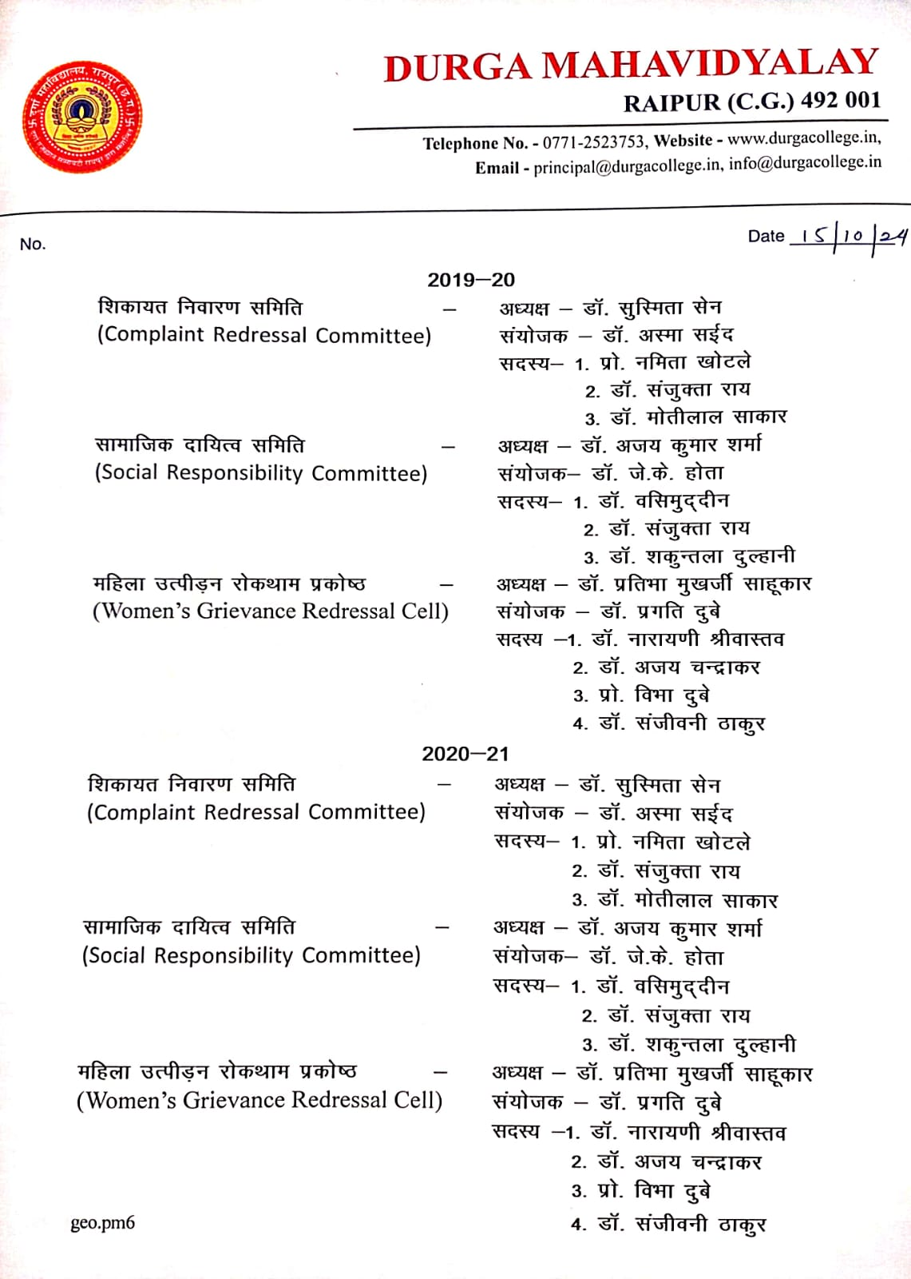

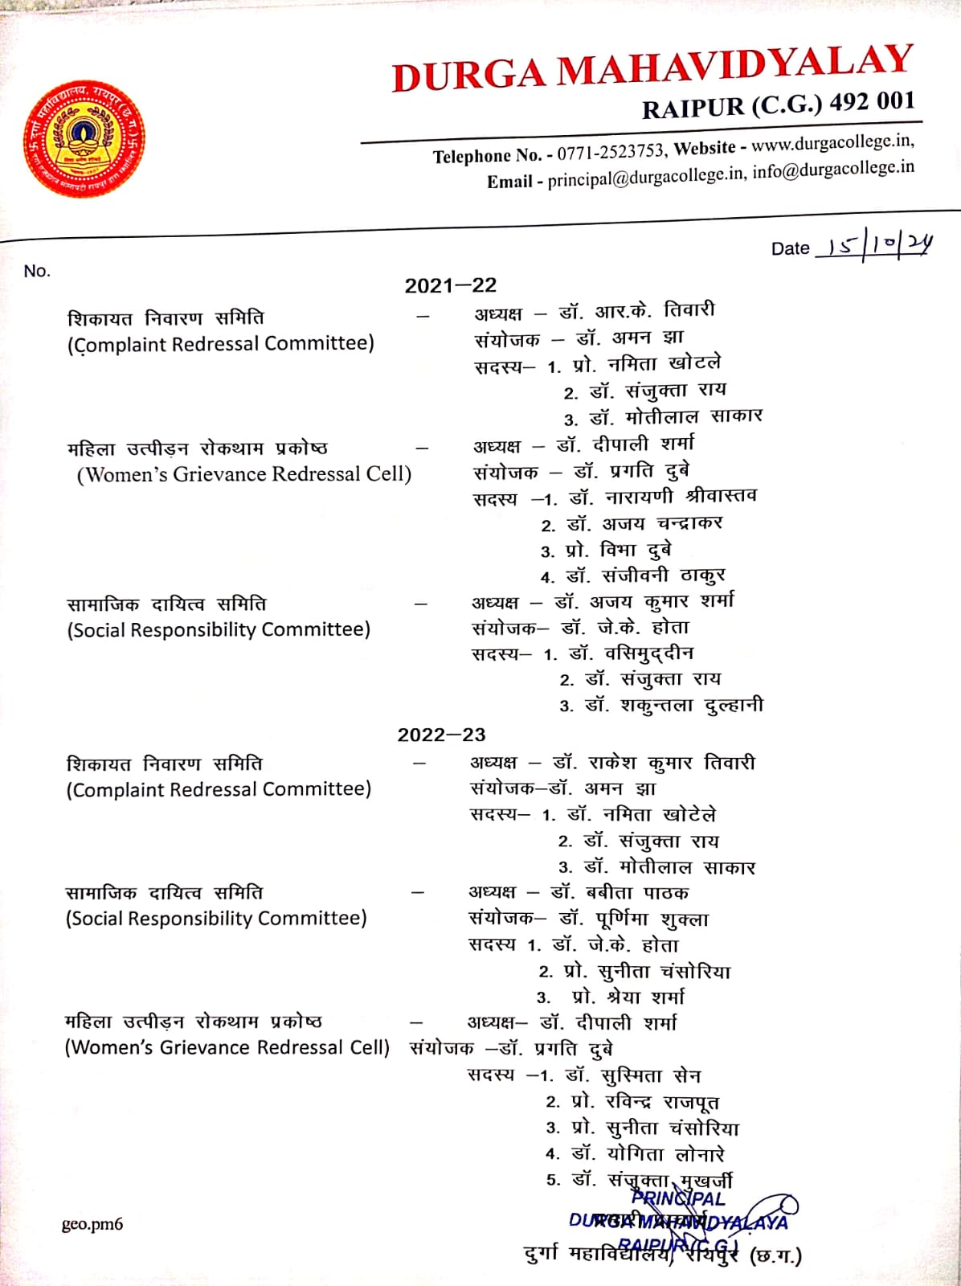
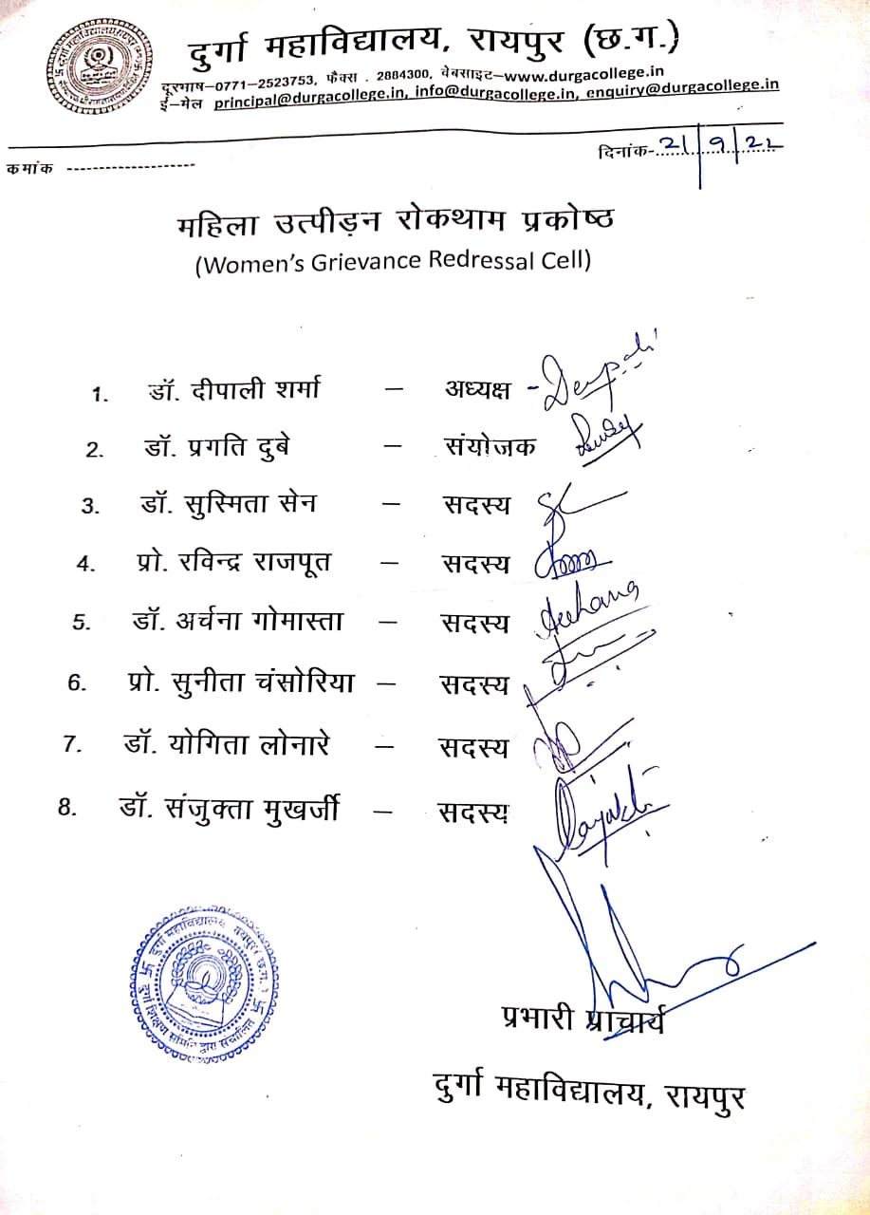

Durga Mahavidhyalaya RAIPUR C.G

Annual Gender Sensitization 21-22

Durga Mahavidyalaya has zero tolerance for sexual harassment and follows all the mandatory rules and guidelines rigorously to ensure a harassment and discrimination free campus.
It stands committed to take strict action against those indulging in sexual violence or harassment of any kind towards its stakeholders.
Here is the list of programs that The Women Development Cell under the aegis of Women’s Grievance Redressal Cell sketched for the academic year 21-22
- Conducting regular awareness raising activities among the students and the staff.
- Workshops on Understanding Sexual Harassment on Campus
- Celebration of Iinternational Women’s Day by honoring the non-teaching women employees of the institute.
- Workshop on “Stree Swachatha”
- Workshop on Gender Discrimination and Gender Role.
The cell thoroughly plans for the coming year albeit under the shadows of Covid-19, still trying to make this year a fruitful one.

Chairperson
Women’s Grievance Redressal Cell

Rules of Committee
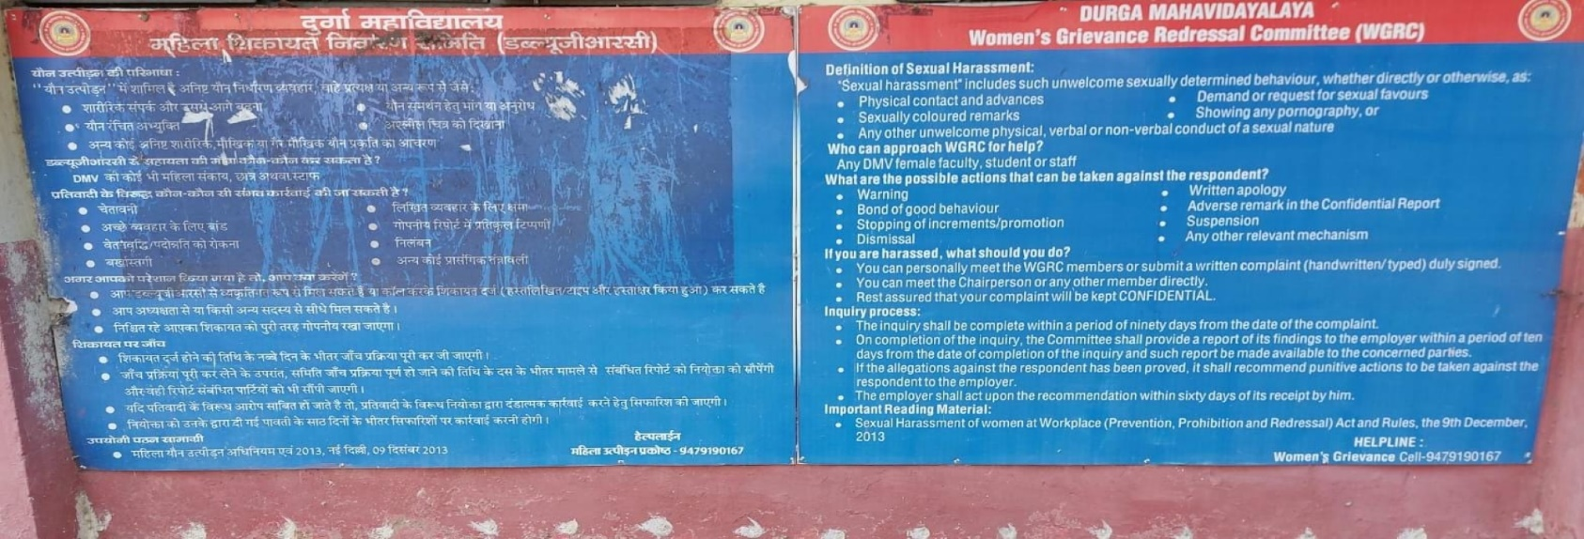
Minutes of meeting
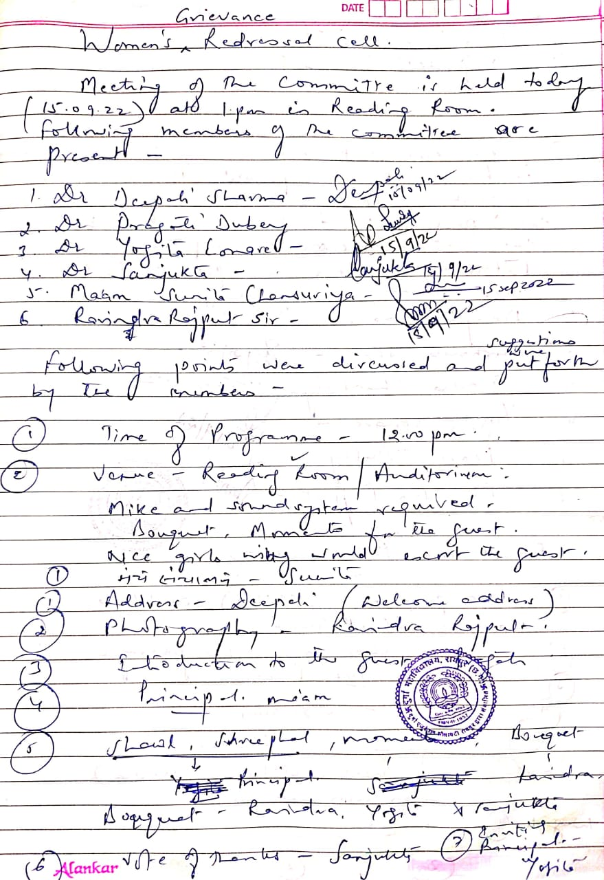

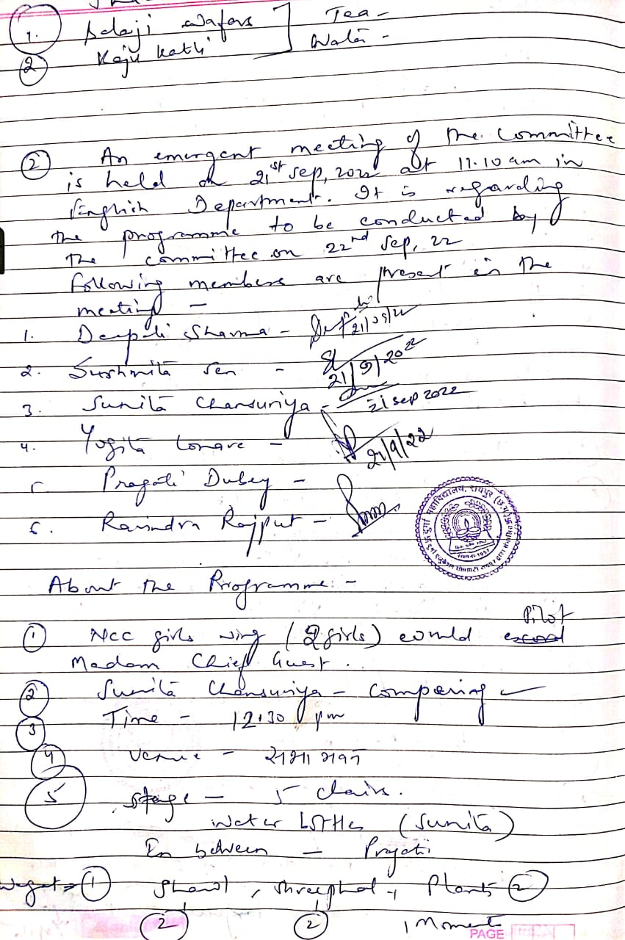

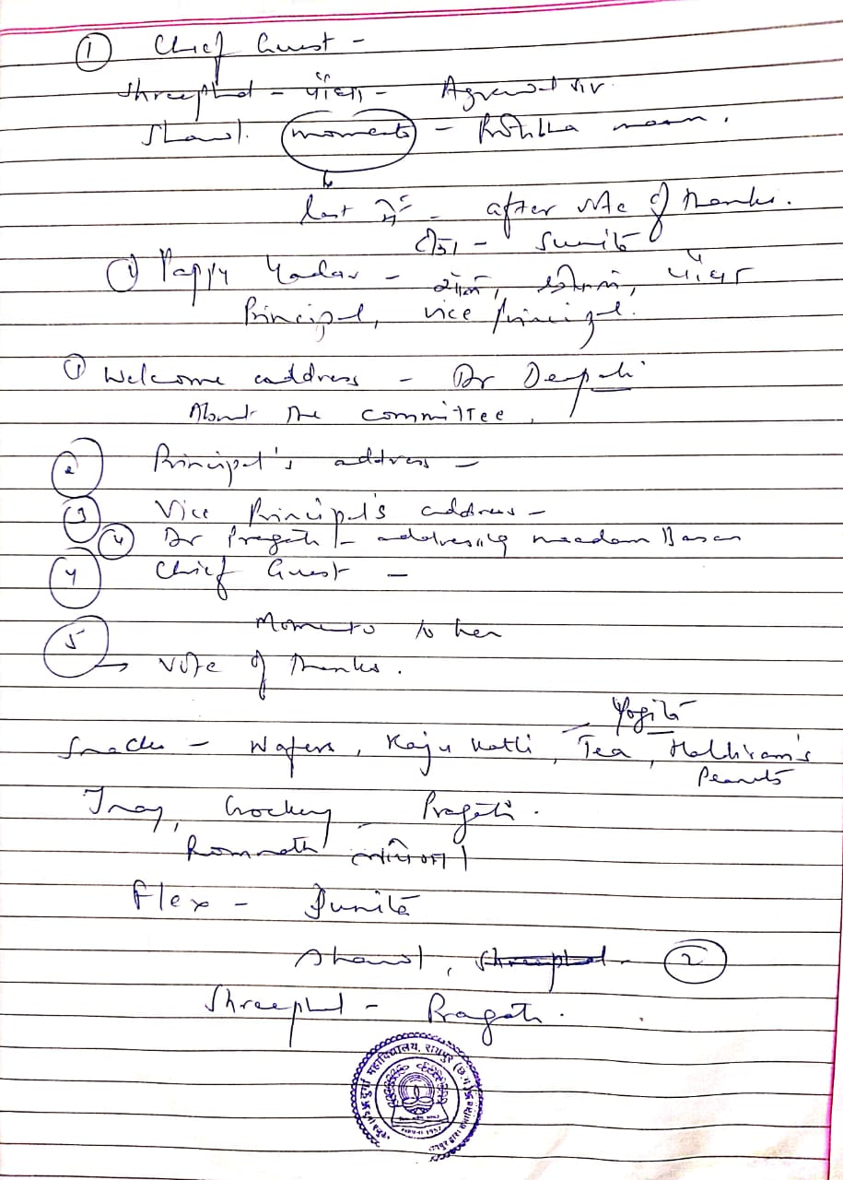

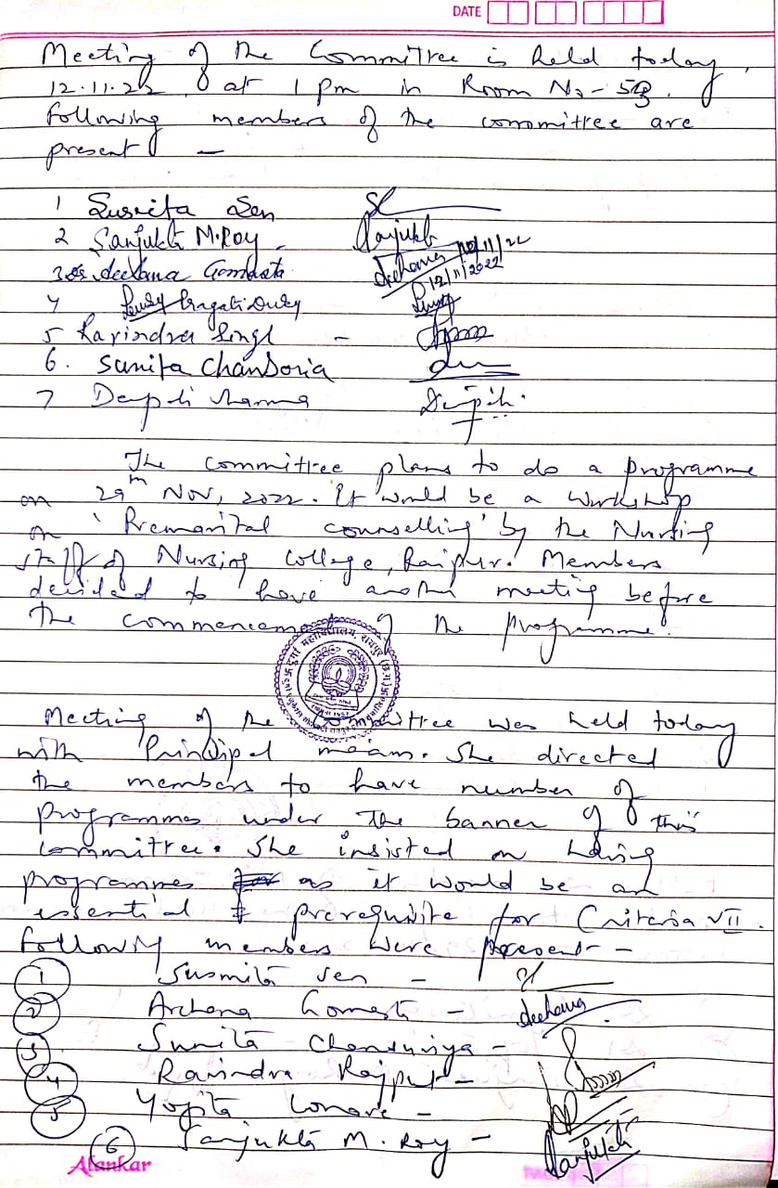

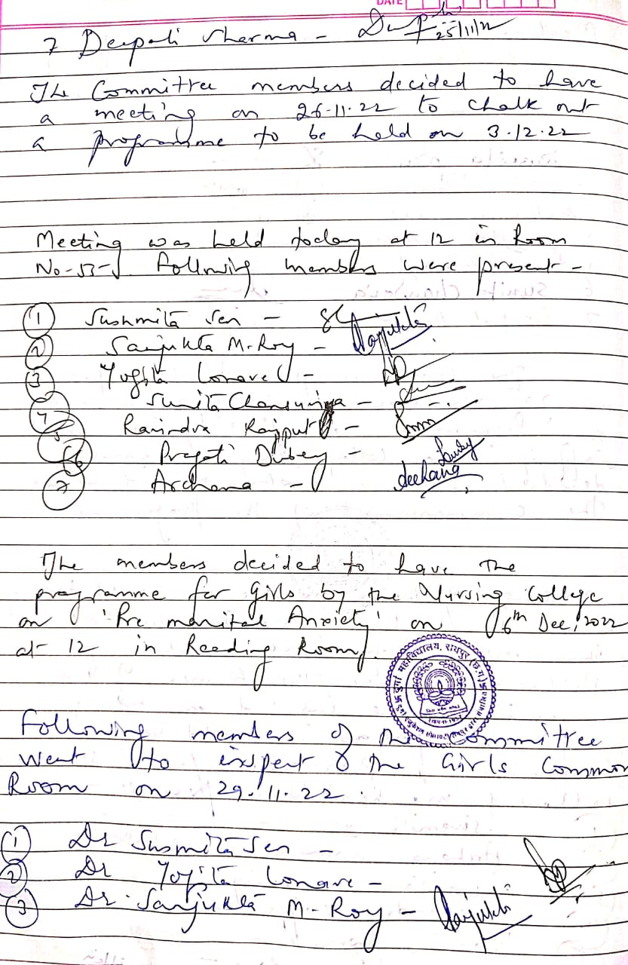

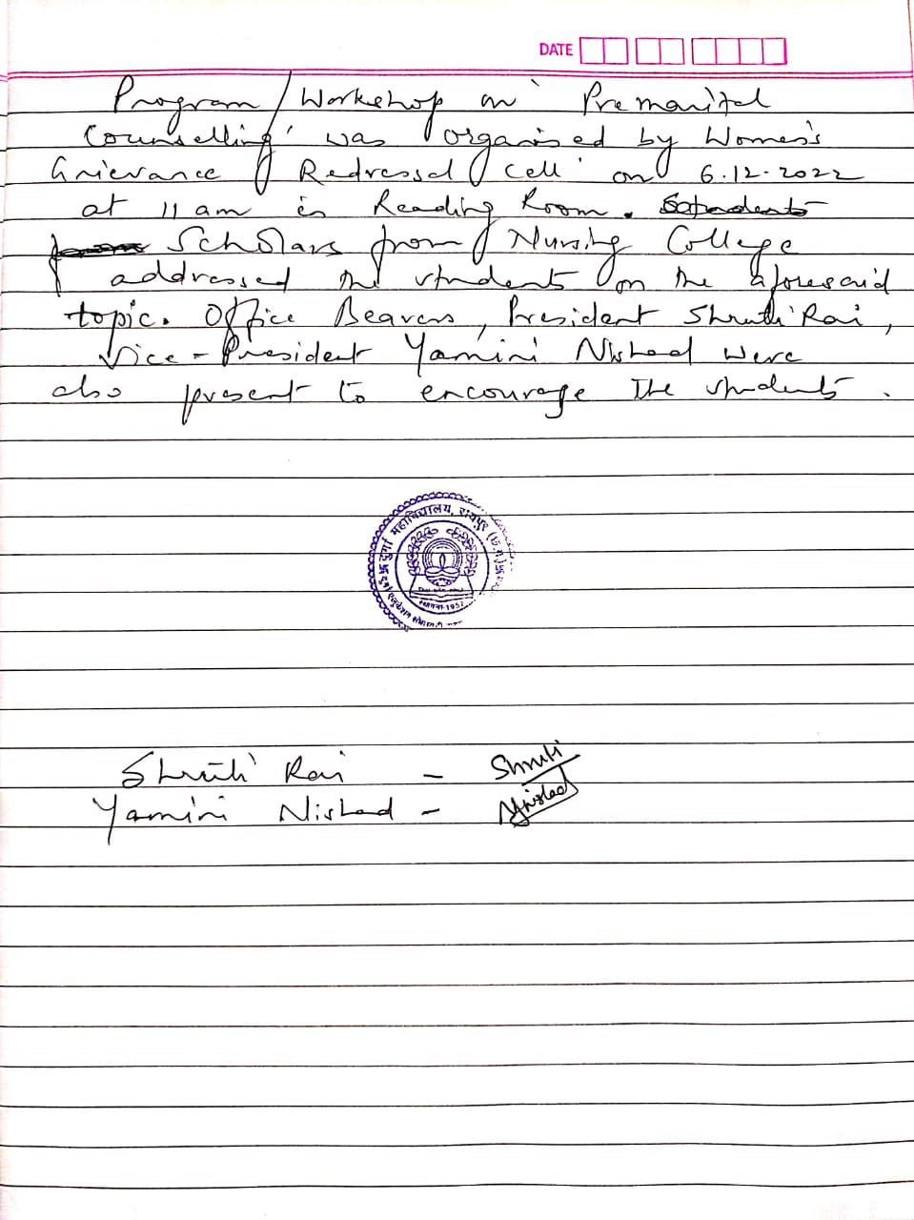

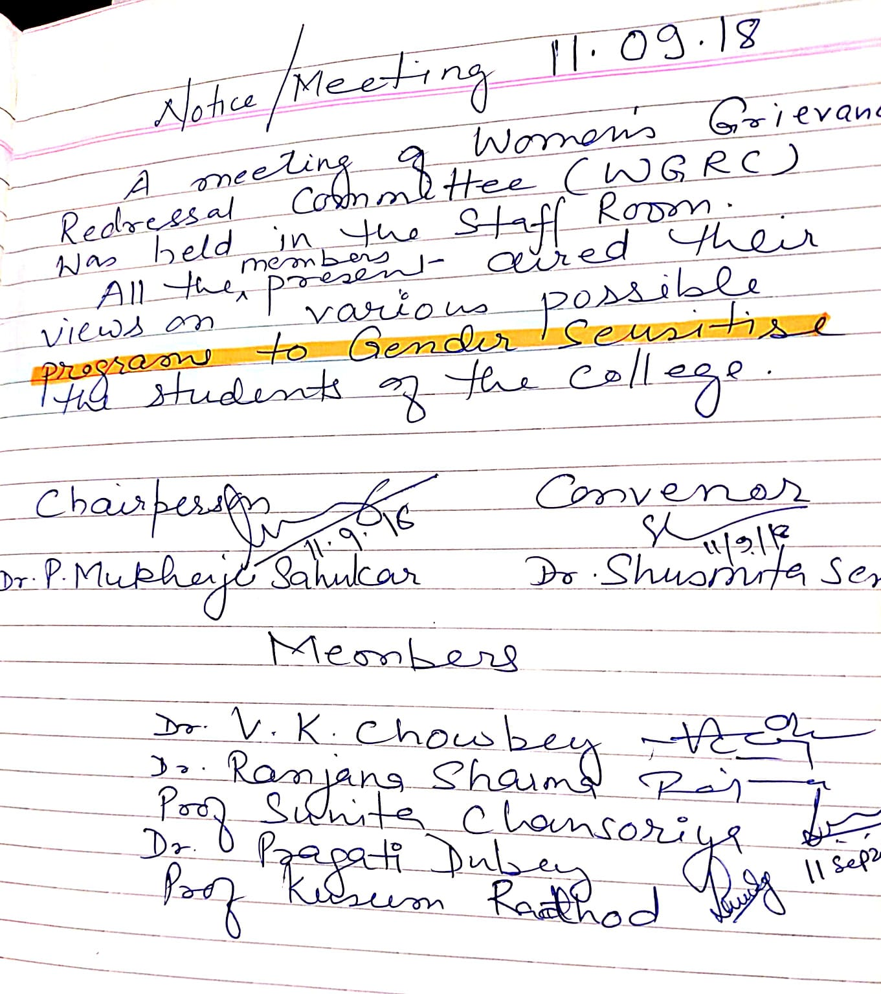

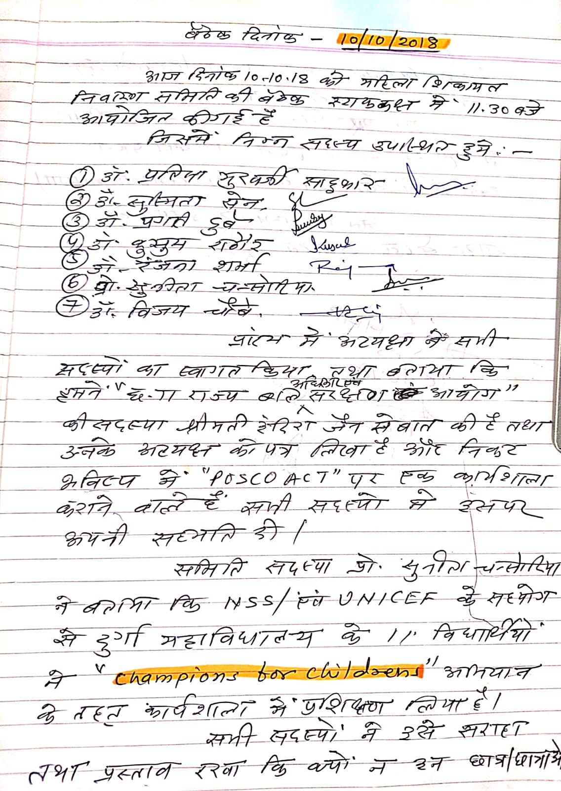

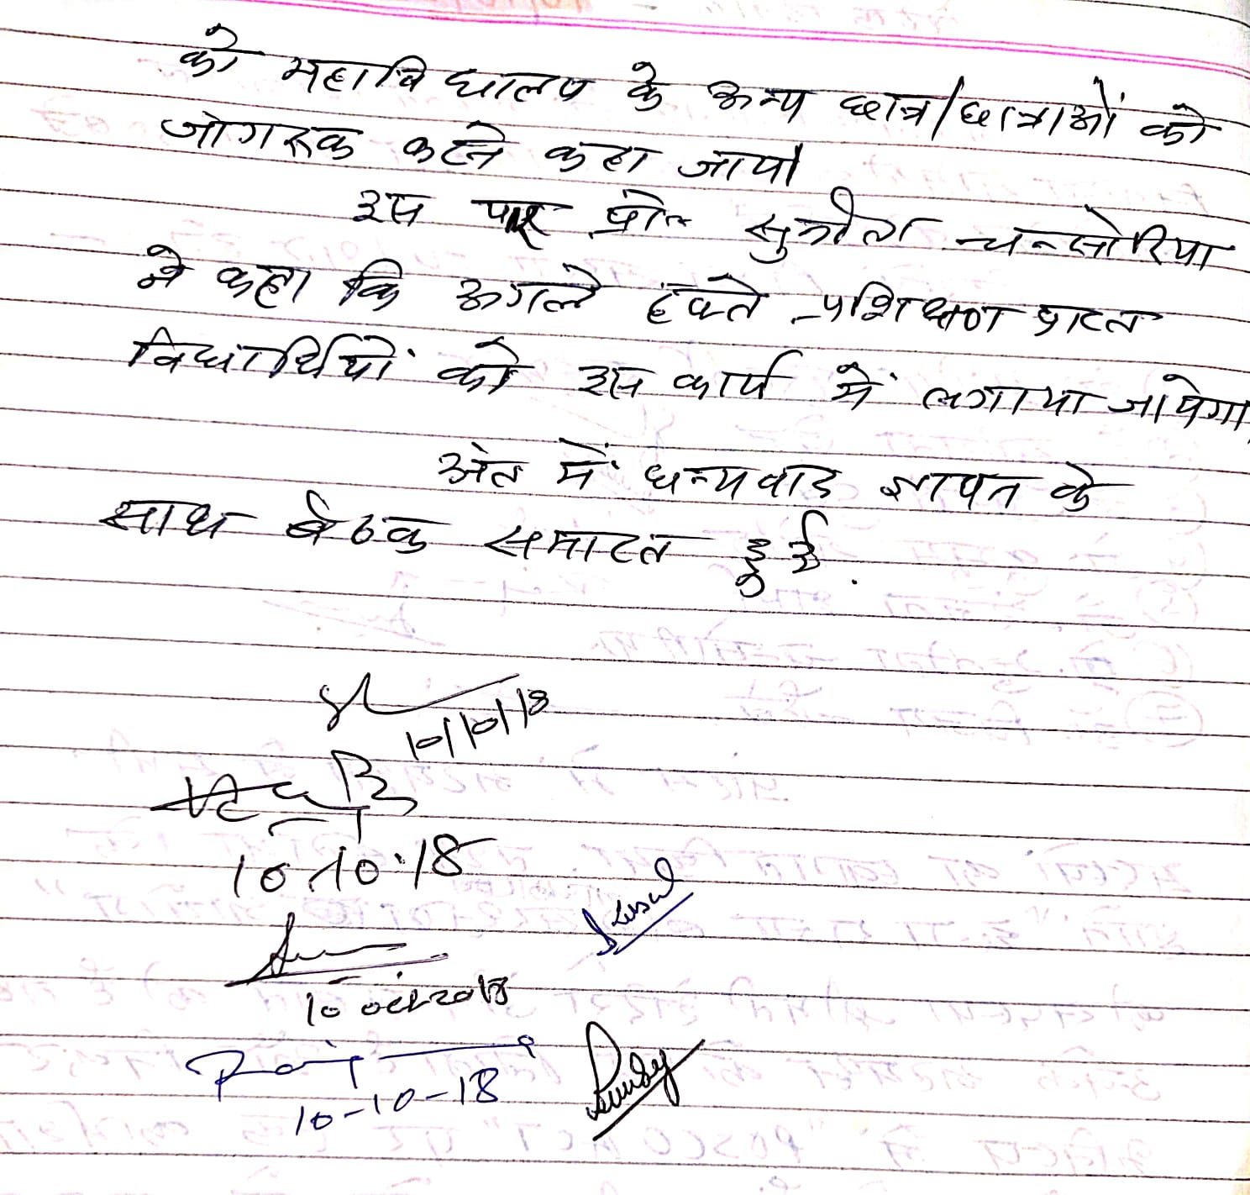

NOTICE
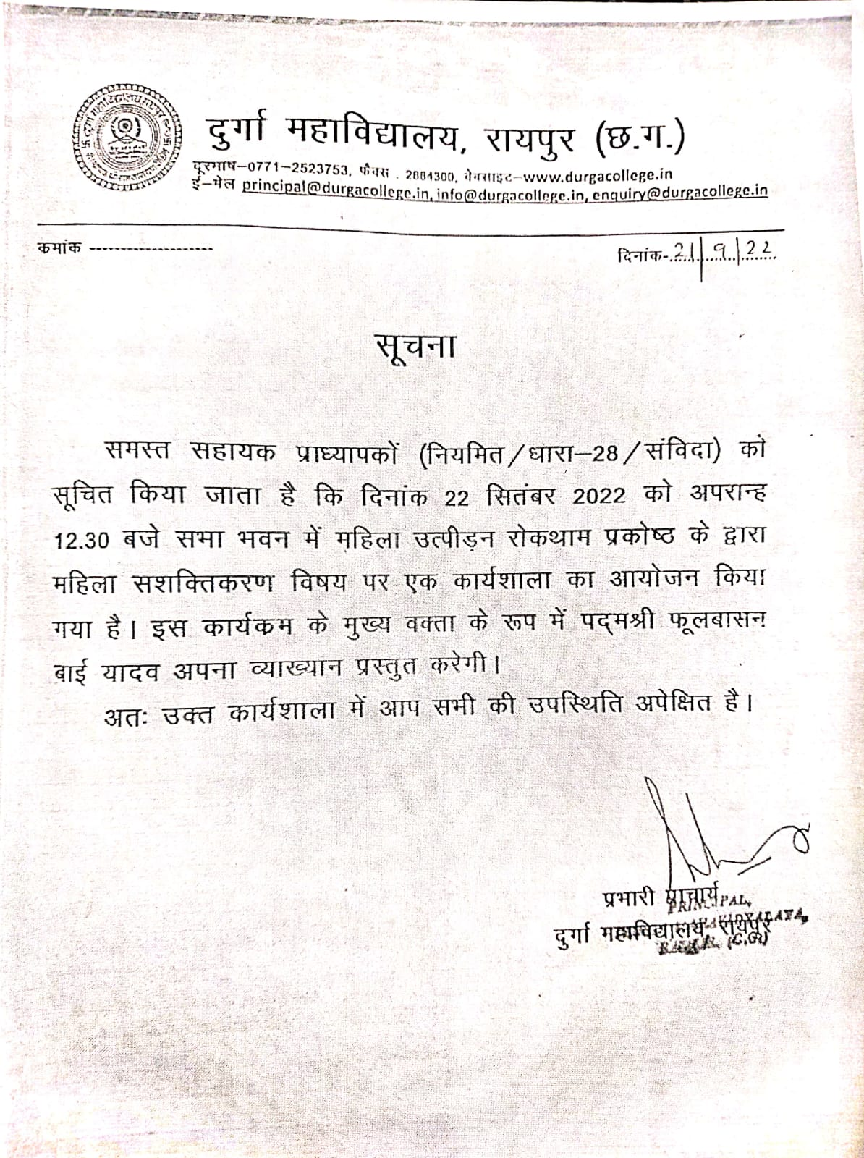

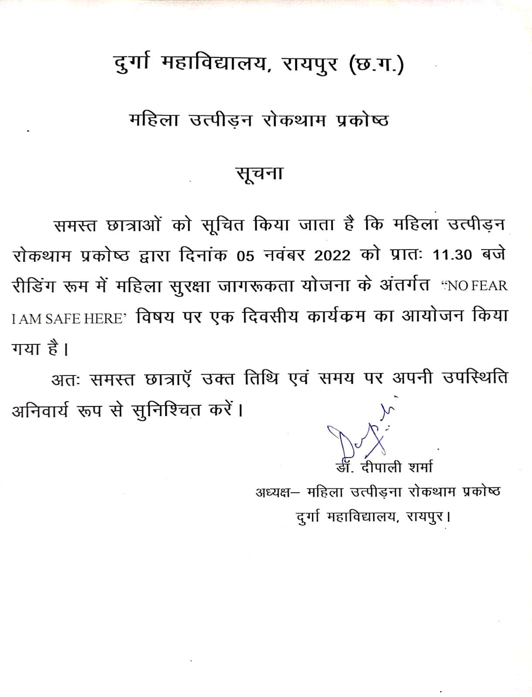
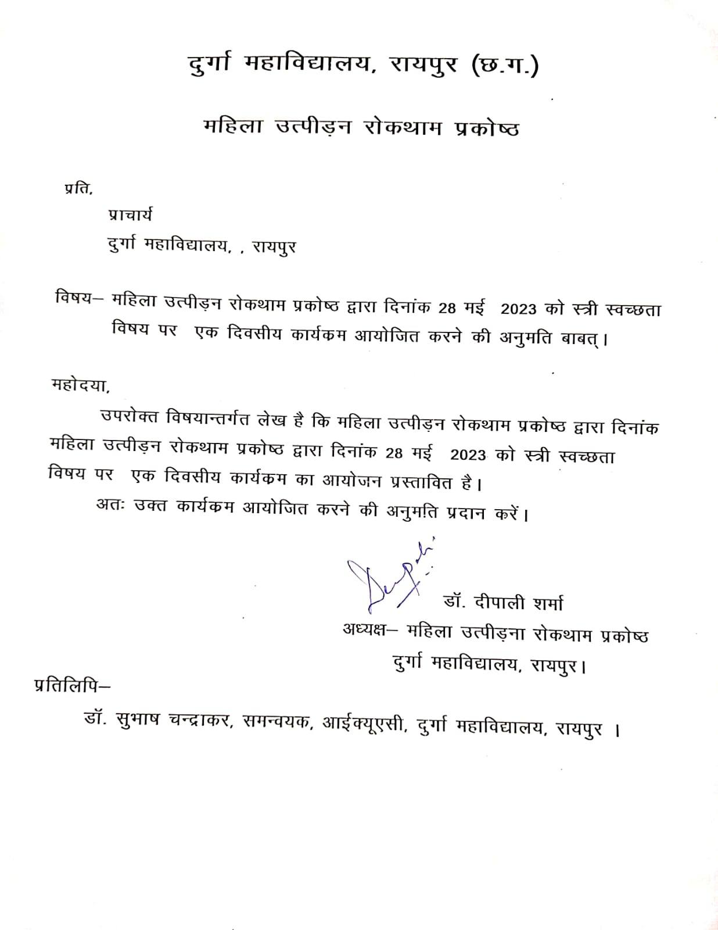

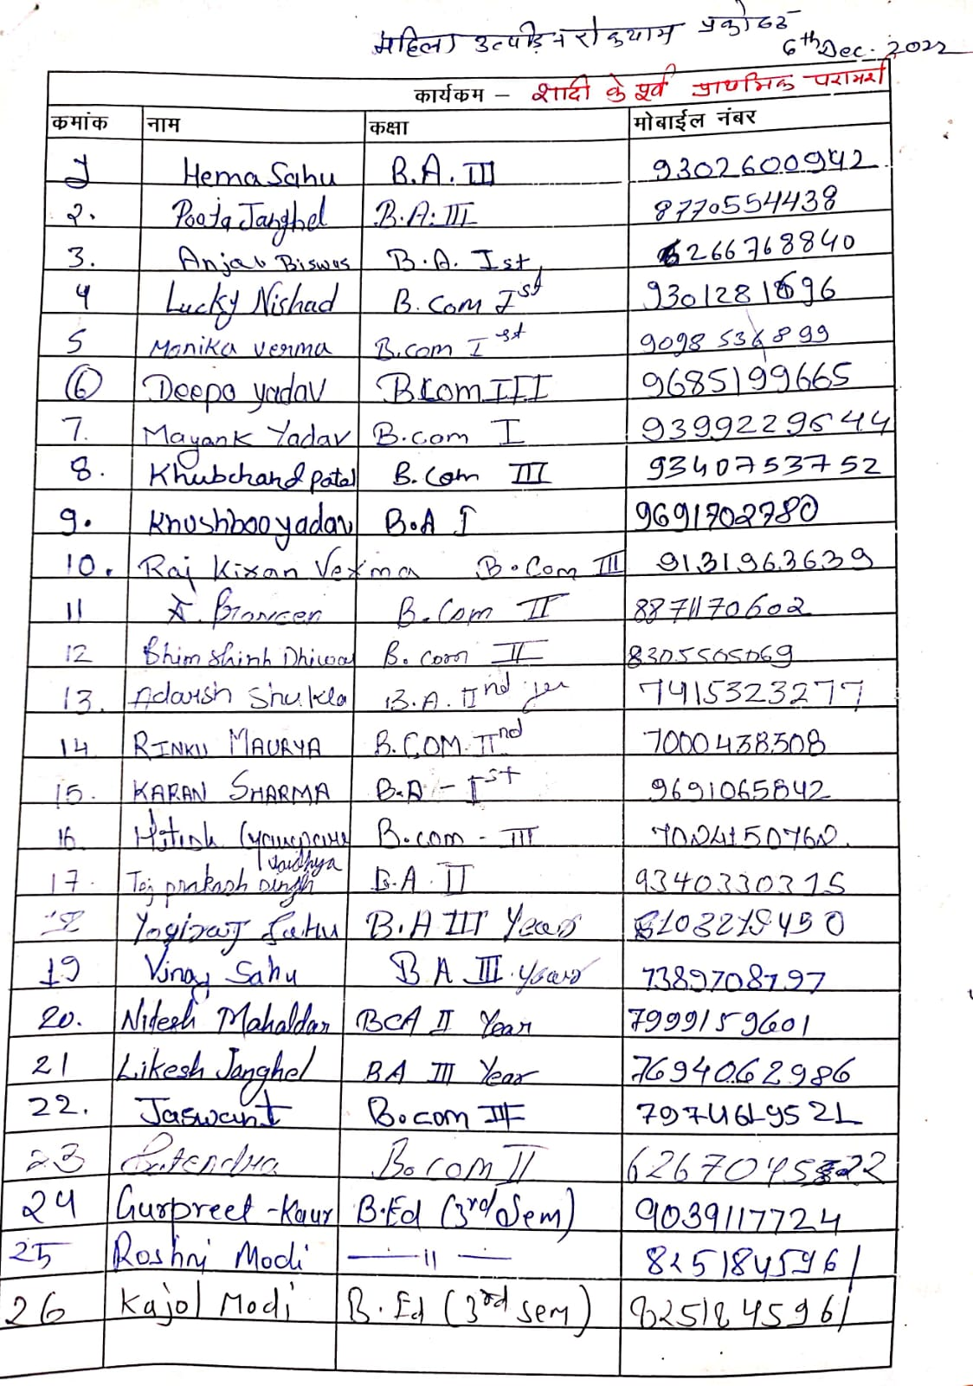

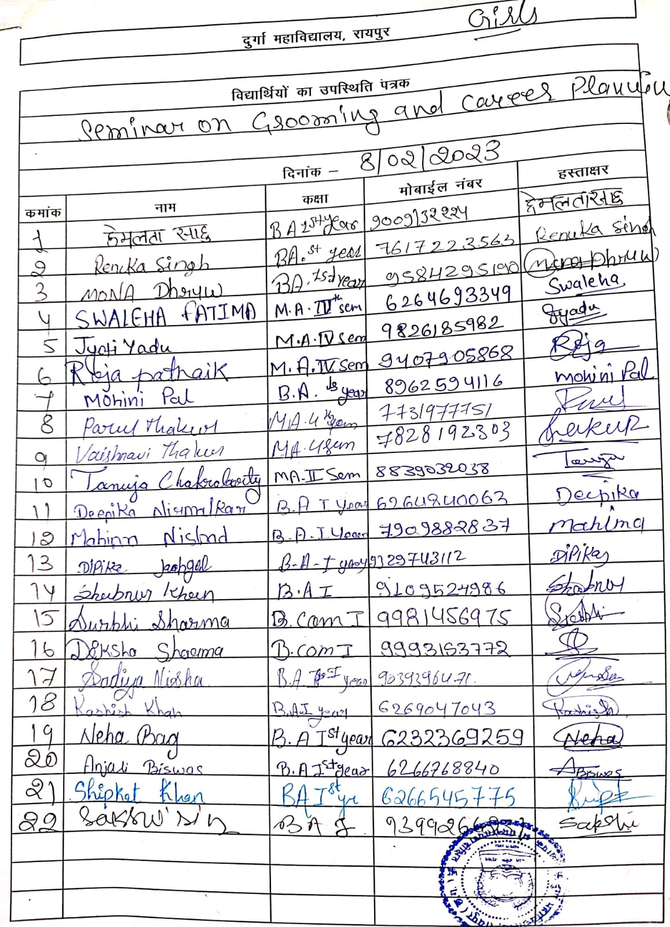
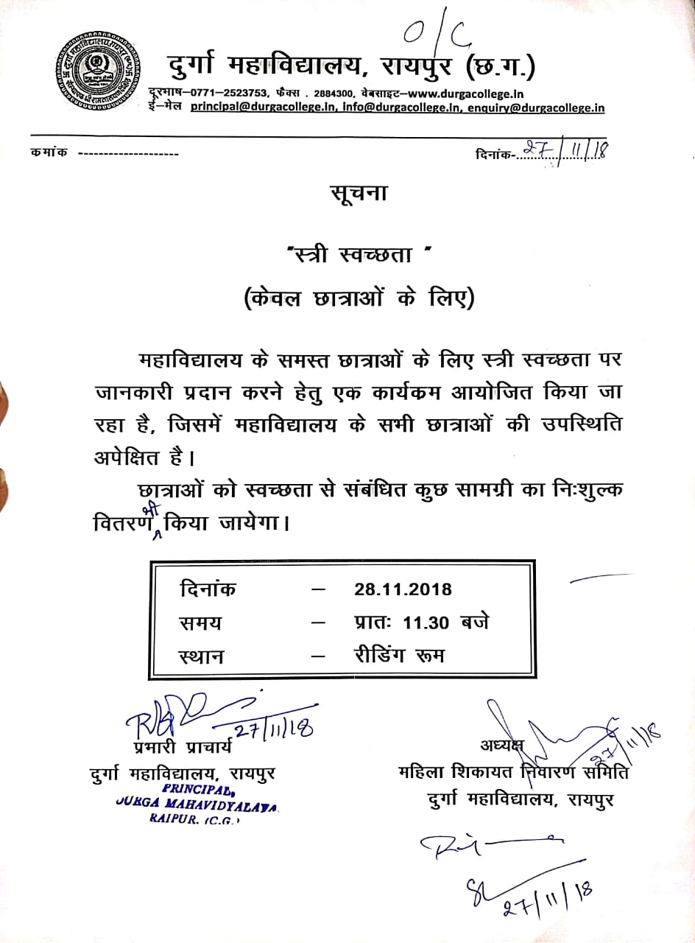

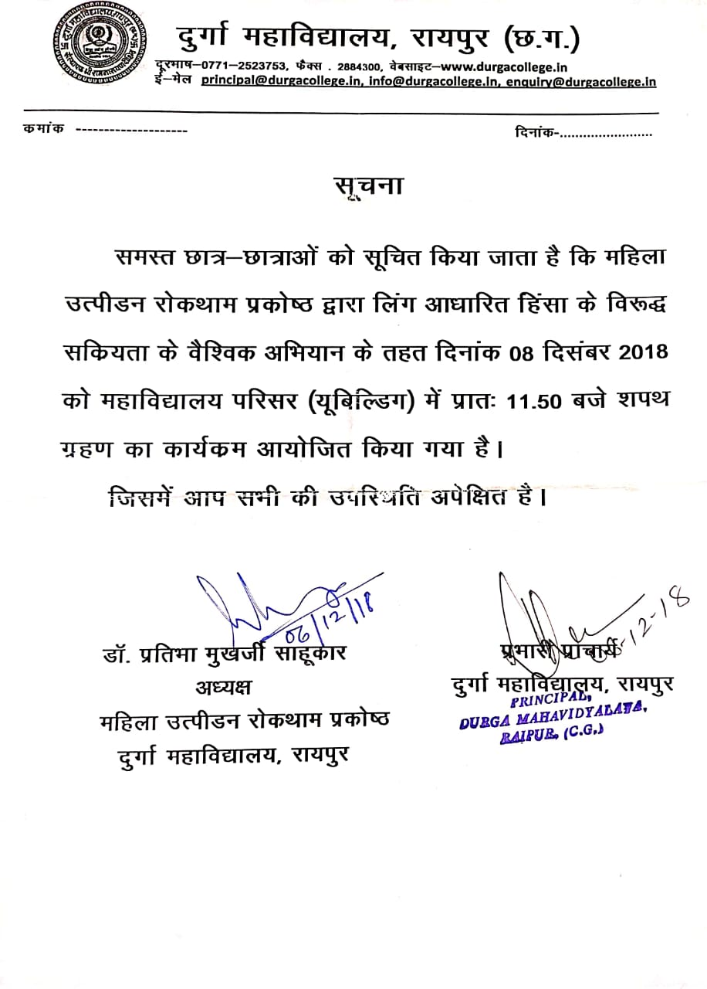

Report
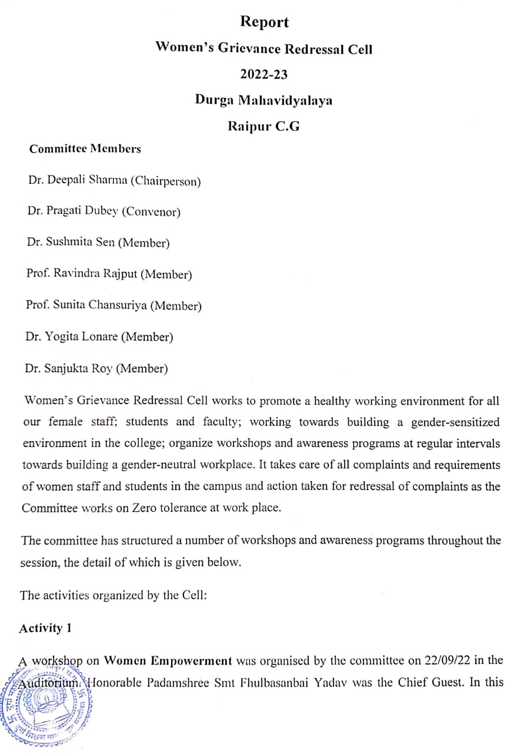

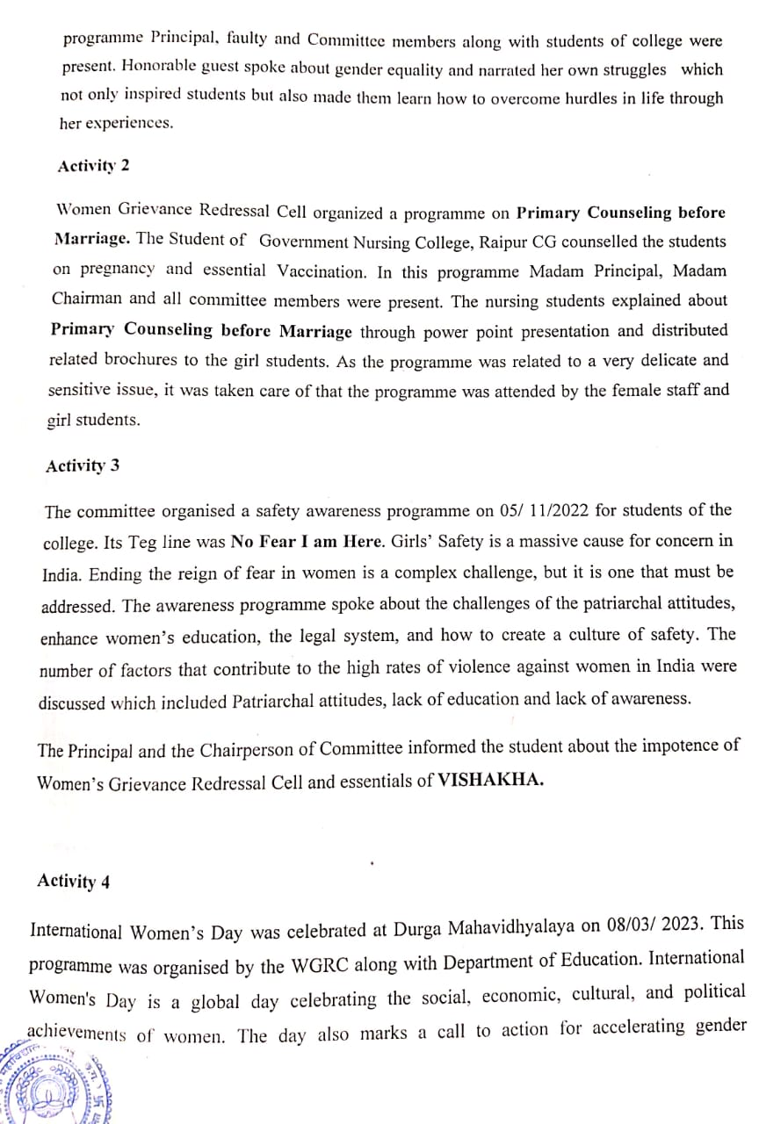

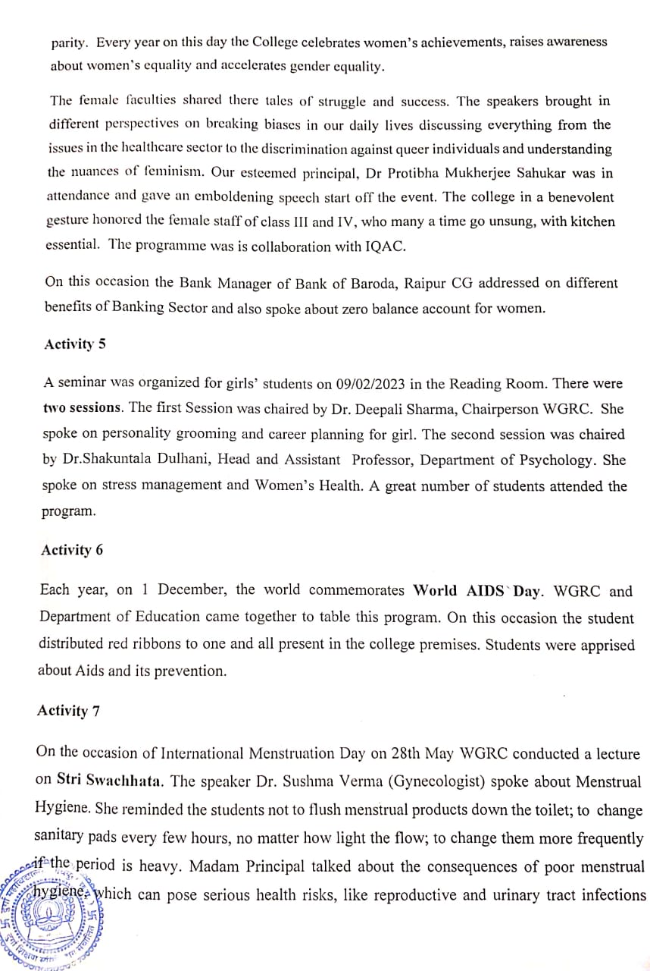

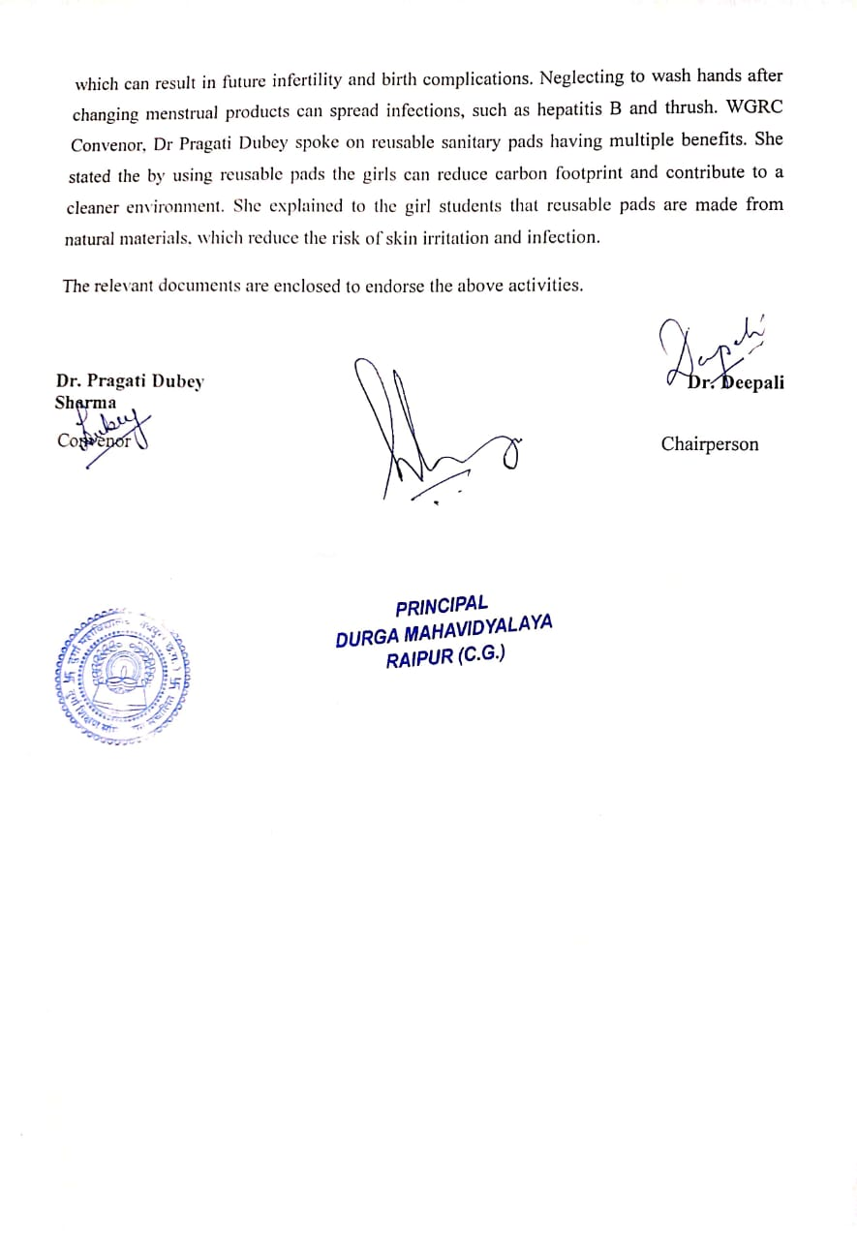
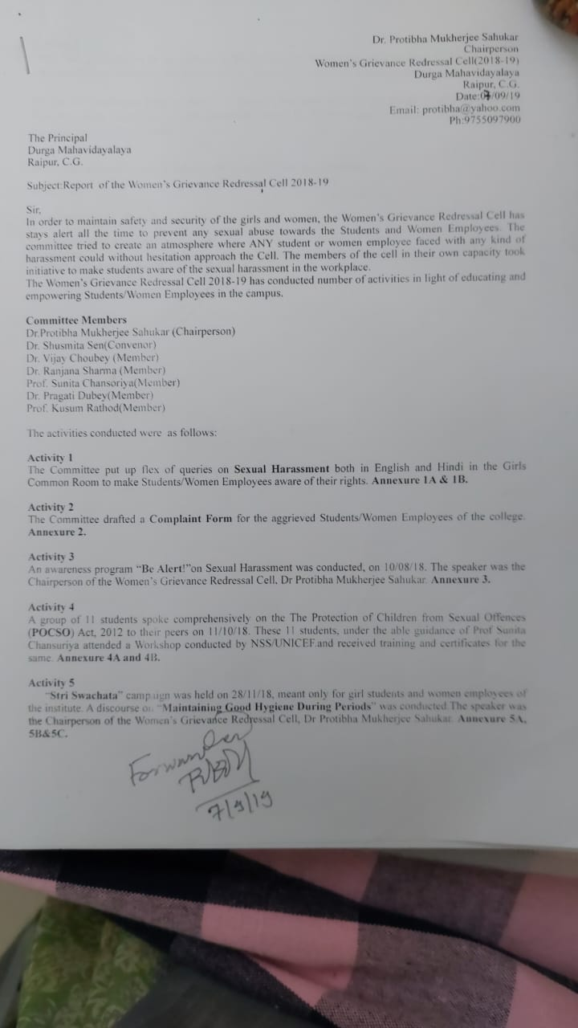
Report
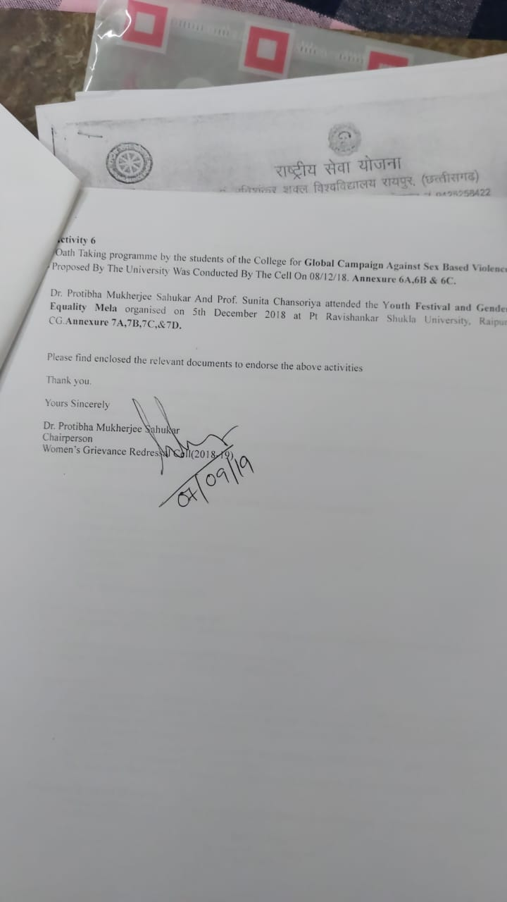

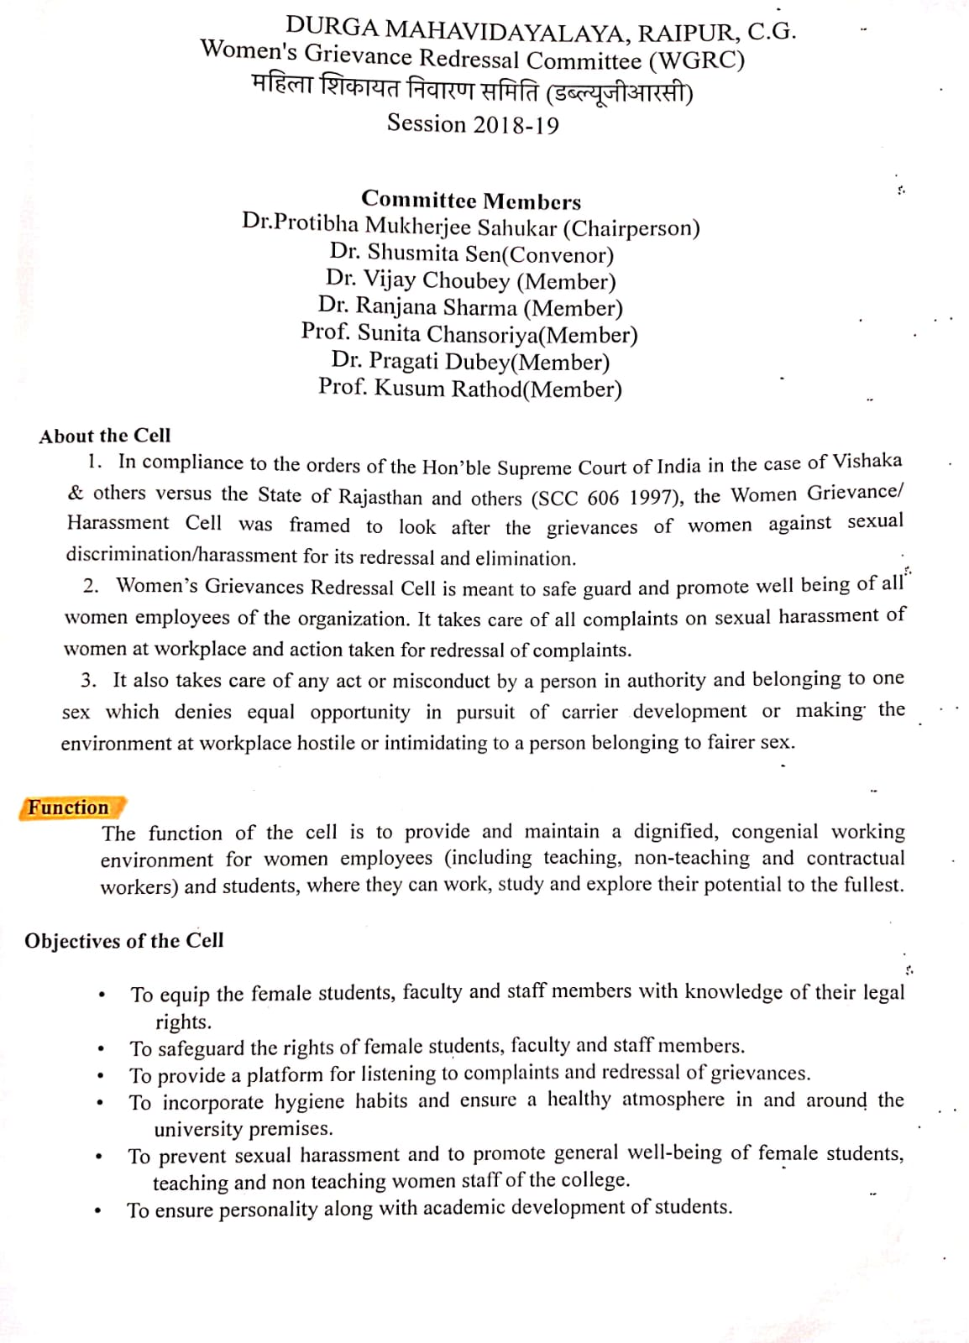
About the cell
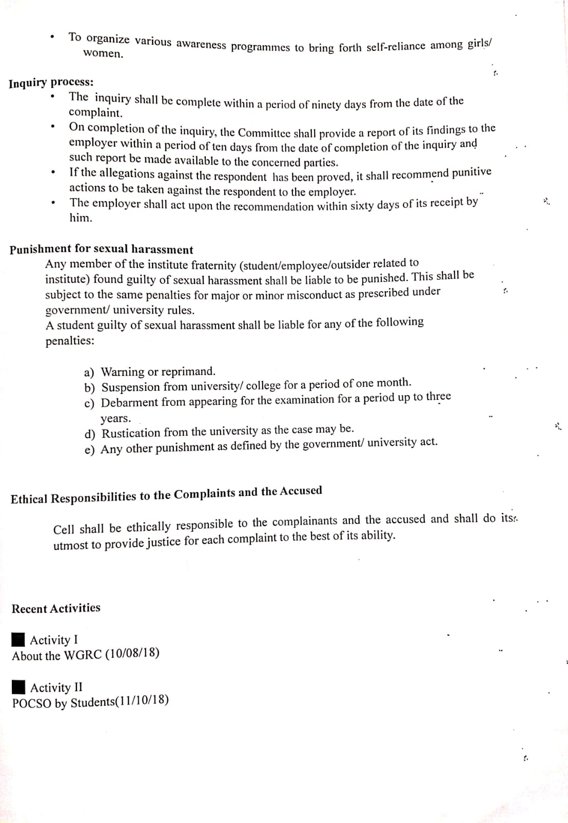

Press release
